PRESS RELEASE
July 21, 2014

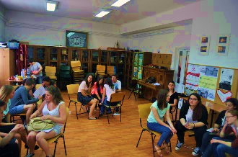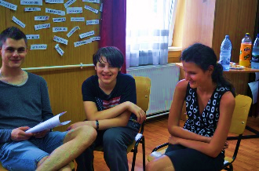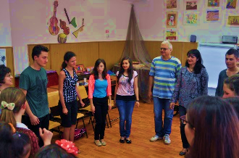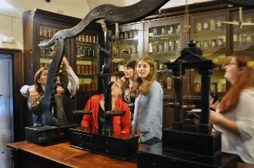

Babilon Travel NGO has completed the first phase of the project
Terra Mirabilis: Tourist Tracks for Visually Impaired Young People

Babilon Travel NGO completed the first part of the project Terra Mirabilis, a local project that aims to create a tourist trail for the blind or visually impaired in the historical center of Cluj-Napoca.
The project started on April 2, 2014, with the signing of the contract concluded with the Municipality of Cluj-Napoca and will end on November 30, this year. The Terra Mirabilis project was written by Babilon Travel NGO together with an informal group composed of four young enthusiasts, including a blind and one with reduced social opportunities.
Project beneficiaries are young (or not so young) blind or visually impaired, from Romania and abroad, who wish to visit the city of Cluj-Napoca and to discover its historical, multicultural and multiethnic background.
In order to achieve this, Terra Mirabilis project aims to develop material support to document and describe the tourist trail and train a group of volunteers to be able to safely accompany blind persons or groups, on this route.
The material support consists of travel guides, maps and promotional materials, that allow a person or group of persons with visual disabilities, to travel safely on a route across the historical center of Cluj-Napoca, route encompassing most representative tourist attractions, monuments and places of worship, emphasizing the multicultural, multiethnic and European dimensions of the city. Material support, in Romanian and English, will be created in formats suitable for people with visual disabilities, i.e. tourist guides printed with large fonts, in Braille alphabet, accompanied by tactile maps and charts and audio guides. Also these materials will be available in digital format (MP3 and PDF).
The Terra Mirabilis project is intended to lay the foundations for future national and international youth exchanges for blind or visually impaired and to support the programme "Cluj-Napoca: European Youth Capital 2015" and also the project "Cluj-Napoca: European Capital of Culture 2021".
By completing the first part of the project we achieved the following objectives: (1) identifying and documenting a tourist trail in the historical center of Cluj-Napoca together with the corresponding tourist attractions, monuments and places of worship; (2) creating and training a group of 16 volunteers to safely guide visually impaired/blind young people on this route.
The second part of the project will begin on September 15 and will end with the printing of the travel guides and promotional materials and with the testing of the route together by a group of blind young people.
Terra Mirabilis project is supported by the City Hall and the City Council of Cluj-Napoca, through the Tourist Information Center of Cluj-Napoca.
Partners: Special School for Visually Impaired Cluj-Napoca, The Ethnographic Museum of Transylvania, Blind People Association Romania, Center for Volunteers Cluj-Napoca.
Sponsor: Class Shoe Romania.
More information on our website babilontravel.ro or please contact us at office@babilontravel.net.

